Ballymun to City Centre
Core Bus Corridor

Feasibility Study and Options Assessment Report Addendum – Option St Mobhi Road
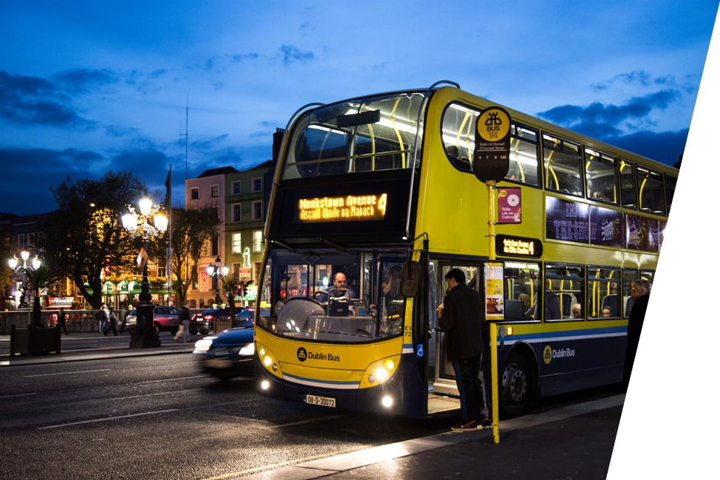
July 2018
Table of Contents

Introduction …………………………………………….………………………………………………………………..2
Route option (BC 10)………………………………….………………………………………………………………..2
Assessment Methodology ……………………….…………………….……………………………………………..5
Option Assessment………………………………….………..………………………………………………………..5
Summary assessment and recommendation....…………………………………………………………………..12
Emerging Preferred Route..…………………………………………………………………………………………..13
Concept Design emerging preferred route ………………………………………………………………………..14
Population Catchment…..……………………………………………………………………………………………..18
Introduction

This report serves as an addendum to the Ballymun to City Centre Core Bus Corridor Feasibility Study and Options Assessment Report and should be read in conjunction with that report. Following that feasibility study and route option selection process an emerging preferred route was identified for the Ballymun to City Centre Core Bus Corridor (CBC). Details of those studies and the resultant Emerging Preferred Route (EPR) are given in the Ballymun to City Centre Core Bus Corridor Feasibility Study and Options Assessment Report.

As part of the on-going studies for BusConnects project a further option has been developed for the section of the Ballymun to City Centre Core Bus Corridor on St Mobhi Road between Griffith Avenue and Botanic Road. This addendum assesses this alternative option for the CBC. It compares this option to the options considered in the main report and goes on to make new recommendations on the emerging preferred route for the Ballymun to City Centre Core Bus Corridor.

Route option (BC 10)
The alternative route option runs from Griffith Avenue to Botanic Road and falls within the area outlined as BC in the map below. The Ballymun to City Centre Core Bus Corridor Feasibility Study and Options Assessment Report identified and assessed 9 feasible scheme options through this section of the CBC. These were labelled BC 1 through to BC 9. The option which is the subject of this report will is labelled BC 10

This alternative option delivers the cycle facilities and bus lanes on-line while retaining many of the mature trees along St Mobhi Road.

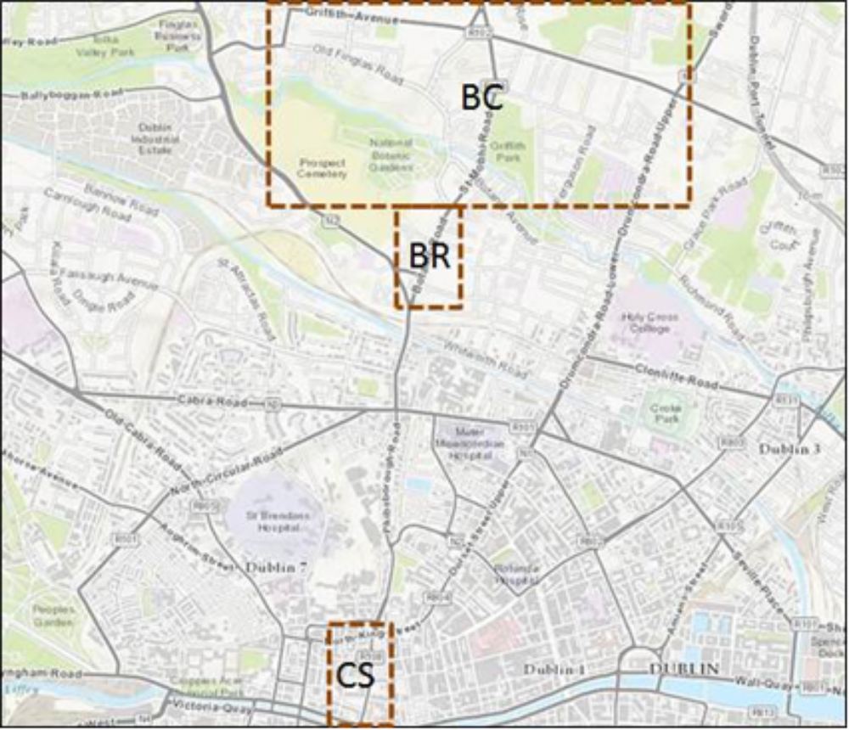

Figure AR 1 Location
Route option BC10, via Mobhi Road, is presented in Figure AR 2

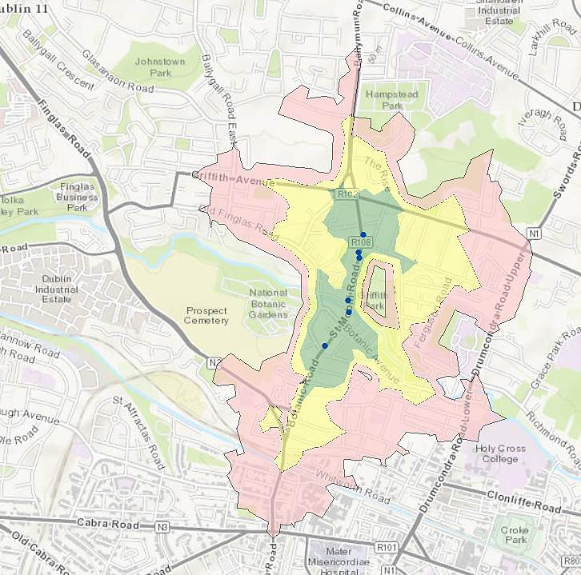
Bus stops
Existing stop
Proposed stop
Population
5 min distance
5 - 10 min distance
10 - 15 min distance

Figure AR 2: Route Sub - Option BC10 St Mobhi Road

Outbound: The CBC service will proceed in a northerly direction along St Mobhi Road (R108) between the junction with Botanic Road/Fairfield Road and the Griffith Avenue junction along the route of the existing QBC.
Inbound: The inbound option follows the same route as outbound.
Stops: It is anticipated that there will be a similar number of bus stops (3 in each direction) compared to the existing situation.
The journey time for this route option from the Griffith Avenue junction to Fairfield Road junction is 5 minutes over a distance of approximately 1.0 km.
It is proposed as part of option BC10 to provide 3m wide bus lanes and 2.0m wide cycle lanes in both directions along St Mobhi Road (which forms part of Primary Cycle Route 3A). Inbound general traffic (heading towards the city centre) will travel along St Mobhi Road whilst outbound general traffic (heading towards Ballymun) will be diverted along Botanic Road, Glasnevin Hill and Ballymun Road. The section of Ballymun Road from between Church Avenue and Griffth Avenue will be made one-way to traffic to facilitate this and likewise St Mobhi Road will be made one-way to general traffic inbound. This traffic arrangement is illustrated in Figures AR 3 and AR 4 below. The provision of these facilities will require acquisition of parts of the front gardens of residential properties which front onto both sides of the road along St Mobhi Road. However most of the trees along St Mhobi Road could be retained although a small number of trees will still be required to be removed for the construction work.. In order to maintain parking in all the affected gardens the standard of the cycle facilities proposed have been locally reduced over short distances to get passed particular pinch points.
Option BC9 in the main report also introduces a one-way system for general traffic but this option BC 10 differs in that these sections of one-way are shorter affording better local access and improved cycle facilities along St Mobhi Road.
The journey time for this route option from the Fairfield Road junction to Griffith Avenue junction is 5 minutes over a distance of approximately 1.0 km. However traffic journey times will be increased for general traffic in the outbound direction. Detours will be required as a result of the one-way traffic systems to either access or egress (depending on the direction of travel) properties on Ballymun Road and St Mobhi Road. The section of Ballymun Road (between Griffith Ave and Church Avenue) and on the section of St Mobhi Road (between Home Farm Road and St Mobhi Drive) would require the longest of the detours.
There are 5 signal controlled junctions along this route as well as 2 signalised pedestrian crossings.
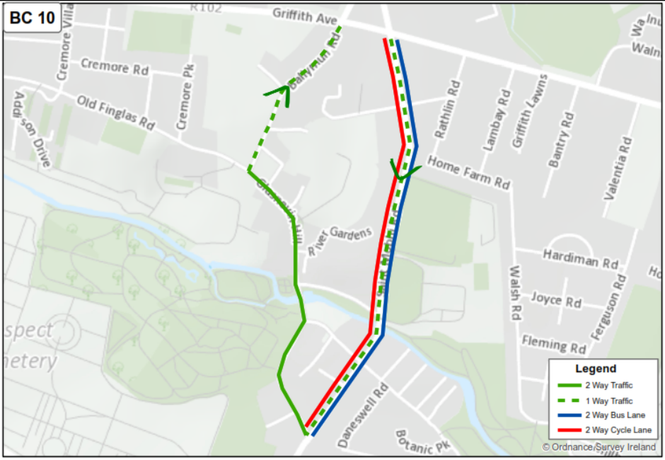

Figure AR 3 Schematic

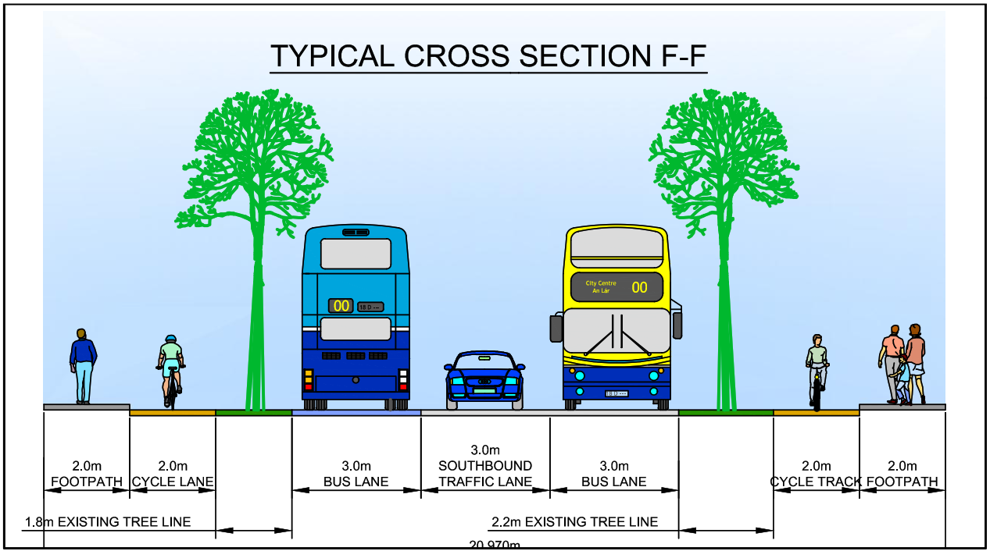

Figure AR 4 St Mobhi Road Cross section

Assessment Methodology
The option is assessed using the same criteria and methods as utilised in the main report. A comparative assessment is used with the option being rated against the options in the main report as follows.
For each individual assessment criterion considered, options have been relatively compared against each other based on a five point scale, ranging from having significant advantages to having significant disadvantages over other route options. For illustrative purposes, this five point scale is colour coded as presented in Table AR 1 with advantageous routes graded to ‘dark green’ and disadvantaged routes graded to ‘dark red’.

Colour | Description
 | Significant advantages over the other options
 | Some advantages over other options
 | Neutral compared to other options
 | Some disadvantages compared to other options
 | Significant disadvantages compared to other options
Table AR 1: Route Options Colour Coded Ranking Comparison Scale

Option Assessment
In this section the option is assessed under the various categories against options BC1 through to BC9 which are presented in the main report

Capital Cost (€9.0M)
Indicative Scheme Infrastructure Works Cost
(€7.0M):
- Introduce bus lanes on St Mobhi Road between Griffith Avenue and Fairfield Road.
- Provision of segregated bus facilities will require significant land acquisition (residential and land of National interest (Botanic Gardens) and loss of on street parking.
- Provide Primary cycle route 3A on Mobhi Road
Introduce a one way system for general traffic which will involve making St Mobhi Road one-way inbound and Ballymun Road one-way north bound as far as Griffith Avenue

Land Acquisition Cost
(€2.0M)
- 1,300 sqm Private Land
- 77 private properties affected

Rank Capital Cost
Significant advantages over other options

Transport Quality and reliability of service
Journey Time: 5 mins
Length: 1 km
No. of Junctions: 5
No. of pedestrian crossings: 2
Full priority provided along route in good journey time reliability for Bus services.
Rank Transport Quality and reliability of service
Significant advantages over other options

Integration
Landuse integration
Integrates with existing residential, educational and leisure uses in this established area.
Rank integration
Some disadvantages compared to other options

Residential and Employment Population Catchments
Residential Population Catchments
- 5 minute walk catchment of approximately 1,700
- 10 minute walk catchment of approximately 4,700
- 15 minute walk catchment of approximately 12,100.

Employment catchments
15 minute walk catchment of approximately 5,500
Rank Residential and Employment Population Catchments
Some disadvantages compared to other options

Transport Network Integration
Potential for interchange with Core Orbital Corridor on Griffith Avenue.
Rank Transport Network Integration
Some advantages over other options

Cycling integration
This route option is identified primary route 3A in the GDA Cycle Network Plan. Both directions of CBC align with route 3A.
Rank Cycling integration
Significant advantages over other options

Traffic Network Integration
While this route involves the retention of CBC/QBC along the R108 general traffic journey times will be increased in the outbound direction. Detours will be required to as a result of the one-way traffic systems to either access or egress (depending on the direction of travel) properties on Ballymun Road and St Mobhi Road. The section of Ballymun Road (between Griffith Ave and Church Avenue) and on the section of St Mobhi Road (between Home Farm Road and St Mobhi Drive) would require the longest of the detours. However the amount of road that is proposed to be one way is less than that proposed in option BC9
Rank Traffic Network Integration
Some disadvantages compared to other options

Accessibility and Social Inclusion
Key Trip Attractors
Education
- Scoil Chatriona
- Scoil Mobhi
- Whitehall College of Further Education

Retail / Leisure
- Na Fianna GAA Club
- Home farm Soccer Club

Employment
- Scoil Chatriona
- Scoil Mobhi
- Whitehall College of Further Education
- Glasnevin National School

Deprived Geographic Areas
Route option serves area of Marginally Above Average means from the Pobal Deprivation Index
Rank Accessibility and Social Inclusion
Some disadvantages compared to other options

Safety
Road safety
No. of Junctions: 5
0 turn movements required in each direction for the bus
Introduction of one way systems result in some more turning movements for general traffic but cyclist have facilities on the desire line.
Pedestrian Safety
Two pedestrian crossings located approximately 50m from existing stops. Footpaths provided on both sides of the road.
Rank safety
Some advantages over other options

Physical Activity
This criterion relates to the health benefits derived from using different transport modes. The subject scheme options under consideration relate to the same mode of travel (bus). As such, this criterion will not produce any relative differences between the options.
The physical benefits associated with the scheme will be quantified as part of a future Cost – Benefit Analysis.
Rank Physical Activity
Neutral compared to other options

Environment ((Archaeology and Cultural Heritage)
A section of this option runs through the zone of archaeological potential recorded as DU018-005. This zone is associated with an ecclesiastical foundation possibly dating from the early medieval period. There are 11 recorded sub-constraints within this area, one of which is located in immediate proximity to the route – DU018-005011 (settlement cluster). However major works are not proposed in these areas.
Rank Archaeology and Cultural Heritage
Some disadvantages compared to other options

Environment (Architectural Heritage)
No. 12 Ballymun Road is a protected structure located to the immediate east of the option.
49 Glasnevin Hill is a protected structure located to the immediate northeast of the option.
The option is located to the immediate east of the boundary wall that surrounds the Botanic Gardens. Three structures within the garden are protected.
Rank Architectural Heritage
Some disadvantages compared to other options

Environment (Flora and Fauna)
Possible land take may impact on existing green areas which are the subject of Z9 (‘To preserve, provide and improve recreational amenity and open space and green networks’)
This option saves most of the trees on St Mobhi Rd however some would be taken down. The area is not believed to be of importance for bats.
Rank Flora and Fauna
Some advantages over other options

Environment (Soils and Geology)
No appreciable impacts
Rank Soils and Geology
Neutral compared to other options

Environment (Hydrology)
No appreciable impacts
Rank Hydrology
Neutral compared to other options

Environment (Landscape and Visual)
Potential negative impacts associated with removal of some trees and reengineering property boundaries. The existing mature trees along St Mohbi road are largely maintained.
Rank Landscape and Visual
Some advantages over other options

Environment (Air Quality)
Possible impacts due to increased trafficking of road networks on the diversion routes. Existing route carries bus traffic already so potential for impacts is lower than other options. Removing outbound traffic from St Mobhi Road would have a positive impact whilst placing this traffic on Glasnevin Hill / Ballymun Road would have a some negative impact.
Rank Air Quality
Some disadvantages compared to other options

Environment (Noise and Vibration)
Possible impacts due to increased trafficking of road networks particularly on Glasnevin Hill and Ballymun Road (section to the south of Griffith Ave) while reduced traffic on St Mobhi Road would be an advantage.
Rank Noise and Vibration
Some disadvantages compared to other options

Environment (Land Use Character)
Any reconfiguration of the existing mature landscaping would have an adverse impact on the character of the street however this options has less impact than other options in this regard.

Rank Land Use Character
Some advantages over other options

Assessment Criteria | Assessment Sub-Criteria | BC1 | BC2 | BC3 | BC4 | BC5 | BC6 | BC7 | BC8 | BC9 | BC10
Economy | Capital Cost
Economy | Transport Reliability and Quality of Service
Integration | Land Use Integration
Integration | Residential Population and Employment Catchments
Integration | Transport Network Integration
Integration | Cycling Integration
Integration | Traffic Network Integration
Accessibility and Social Inclusion | Key Trip Attractors
Accessibility and Social Inclusion | Deprived Geographic Areas
Safety | Road Safety
Safety | Pedestrian Safety
Physical Activity | Physical Activity
Environment | Archaeology and Cultural Heritage
Environment | Architectural Heritage
Environment | Flora and Fauna
Environment | Soils and Geology
Environment | Hydrology
Environment | Landscape and Visual
Environment | Air Quality
Environment | Noise and Vibration
Environment | Land Use Character

Table AR2 Comparison of route options
Summary assessment and recommendation
Option BC1 scored best as part in comparison to other options as assessed in the main report. Option BC1 provides bus lanes, cycle lanes and general traffic lanes on St Mobhi Road but requires some landtake from private property and requires the removal of the trees on St Mobhi Road. Option BC10 as described in this addendum report scores well against other options by providing the required cycle facilities on the route and providing the necessary bus lanes while retaining the trees. The downside is that outbound traffic has to be diverted.
In terms of capital cost option BC10 is cheaper than many options as it involves less construction for carriageway widening.
In terms of environmental impacts BC10 benefits by retaining trees along St Mobhi Road which is deemed marginally better than the negative impacts associated with diverting the traffic. Providing the cycle facilities and bus lanes along the most direct route is deemed to advantageous as it is for option BC1.
For the above reasons option BC10 is seen to be the most advantageous and is now taken forward as part of the emerging preferred route for the Ballymun to City Centre CBC as described below.

Emerging Preferred Route (EPR)
Based on the conclusions from the route options assessment process, as set out in in the main report and as amended in this report the recommended preferred route for the proposed scheme is presented in Figure 9.1
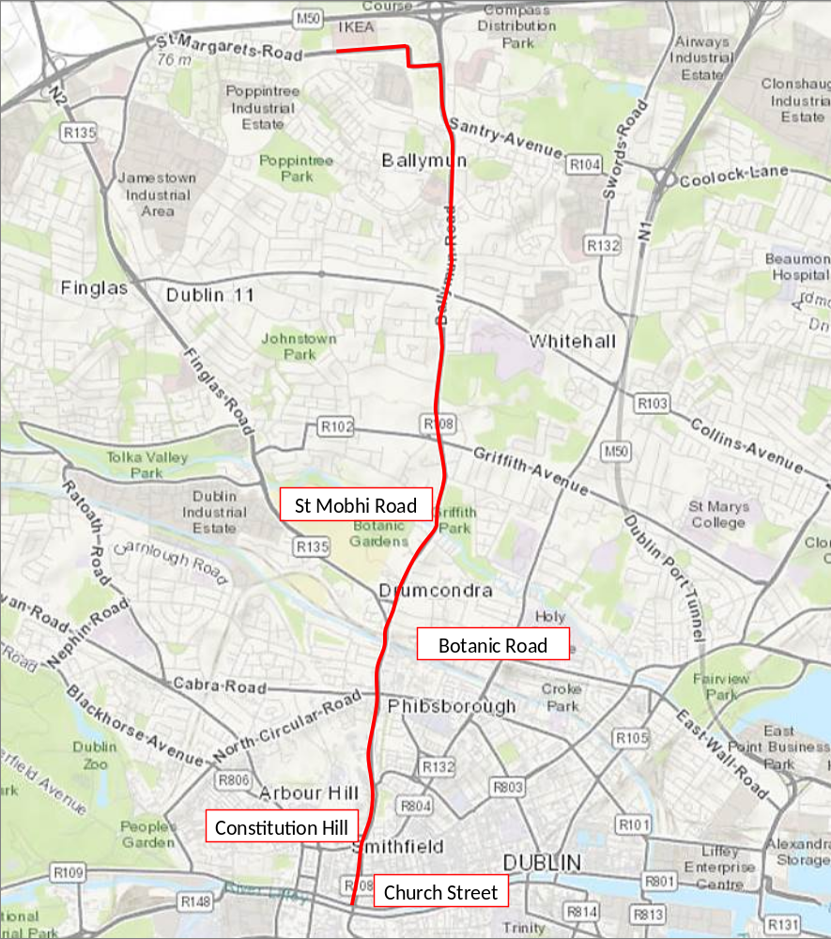
Figure AR 5 Emerging Preferred Route
  - Concept Design emerging preferred route
There are 3 distinct sections of the EPR and these are described in turn below and are outlined in the Concept Design Drawings that accompany this study:

Section 1 St Margarets Road (Ikea) to Griffith Avenue
Length of Section: 4km
Indicative Cost Estimate for Section: €6million
Level of segregated Bus Priority provided: >95%.

The Emerging Preferred Route (EPR) for this section will start at a new terminus to be located immediately south of the Ikea Store on St Margaret’s Road, north of Ballymun. The route will make maximum use of the existing bus lanes which run the full length of St Margaret’s Road and Ballymun Road, with enhancements mainly located at junctions where priority has been maximised. In addition the number of bus stops has been reviewed with some stops removed where there was a significant overlap of stops, in this case mainly around Ballymun town centre.
As part of this scheme the existing cycle lanes along this road will be upgraded in line with current best practise as will the pedestrian crossing facilities at junctions.
Overall the EPR for this section requires an upgrade of existing facilities along its length.

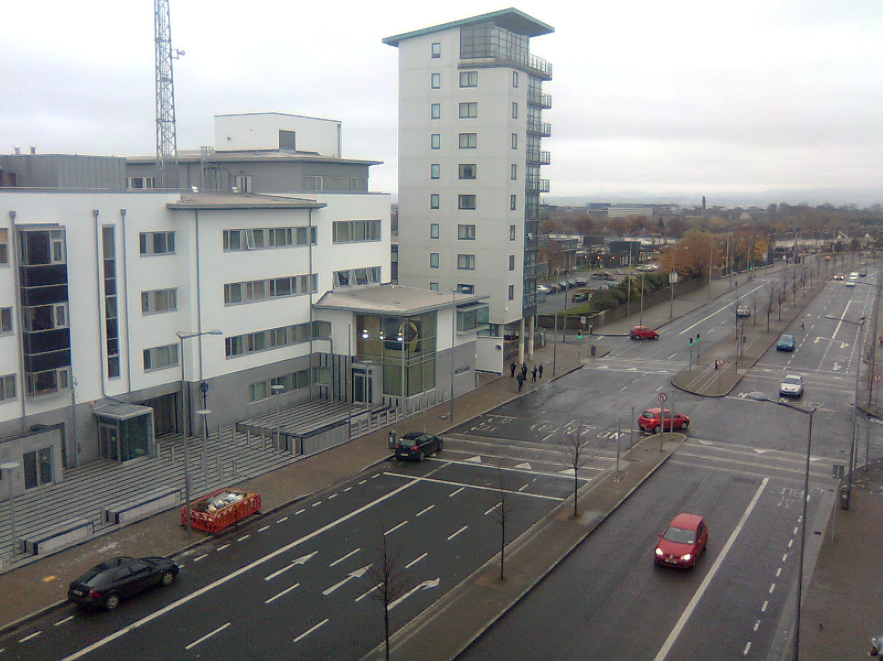

Figure AR 6 Existing Bus and Cycle Lanes on the Ballymun Road (R108).

Section 2 Griffith Avenue to Phisborough (Doyles Corner)
Length of Section: 2km
Indicative Cost Estimate for Section: €13.5million
Level of segregated Bus Priority provided: >85%.

The EPR for this section follows the existing Ballymun Quality Bus Corridor routeing as far as Whitworth Road, where it is now proposed to continue straight to Phibsborough. As this section currently has bus lanes in one direction only a significant upgrade of the existing facilities has been required to bring it in line with the requirements of the Core Bus Corridor infrastructure. This will involve making St Mobhi Road one-way to general traffic inbound from Griffith Avenue to Fairfield Avenue while outbound traffic will divert via Glasnevin Hill and Ballymun Road. In order to retain most of the existing trees on St Mobhi Road some property boundaries will need to be set back to allow the provision of cycle tracks in both directions which will run on the property side of the tree lines. The setback of the existing property boundaries will leave enough of the driveways of the private houses to facilitate off street parking.

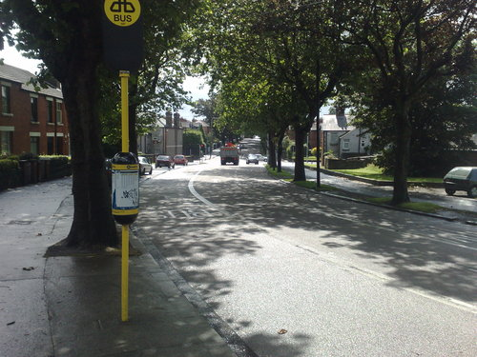
Figure AR 7 Mobhi Road showing existing Mature Trees.

South of Fairfield Road on the Botanic Road it is not possible to provide an inbound bus lane due to the space restrictions and the limited scope to widen this section of road due to the differing ground levels between the street and the adjacent houses. In order to provide bus priority a Virtual Bus Lane will be created through the use of an inbound bus gate at the Fairfield Road junction, where traffic into the following section will be metered so as the inbound queue length never exceeds the length of the subsequent section of bus lane. This is only possible because there is effectively a continuous section of bus lane approaching Fairfield Road which allows the bus to bypass queuing traffic.

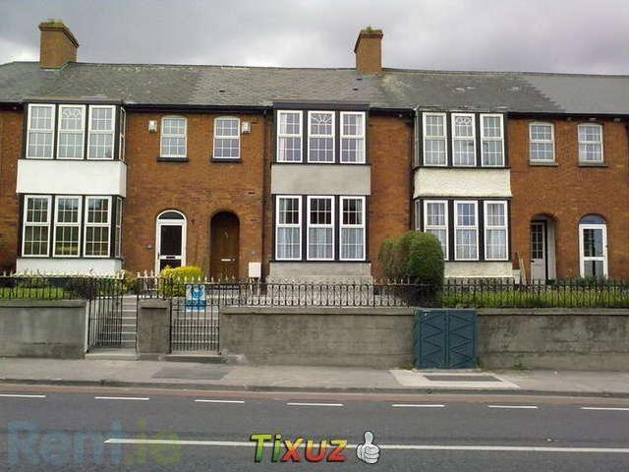

Figure 8 Properties on Botanic Road (Note steps to entrances)

Through Phibsborough the proposed CBC works will be integrated within any future upgrade of the Village. As part of the scheme development additional pedestrian crossings and upgrading of existing crossings is proposed.
Cycle facilities are being proposed over much of this section, however there is insufficient space to provide facilities in line with current design standards for a distance of approximately 0.5km on Botanic Road due to the lack of available space and the geometric constraints mentioned above. In Phibsborough the cycle route is rerouted to an adjoining parallel route in line with the GD Cycle Network Plan. This route uses Royal Canal Bank to provide facilities for cyclists along quiet mainly residential streets.

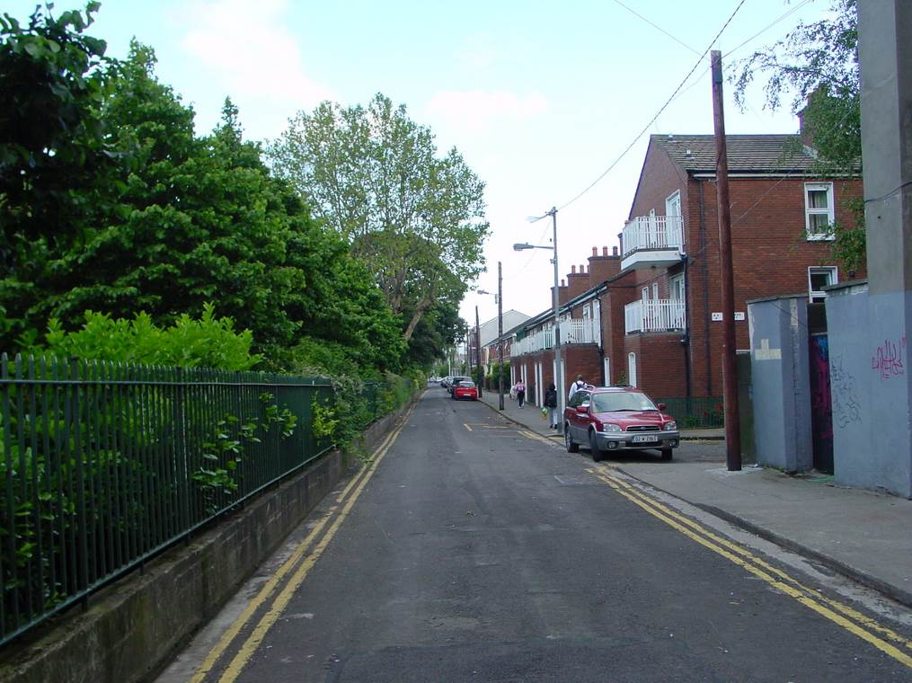
Figure AR 9 Properties on Botanic Road (Note steps to entrances)

Section 3 Phibsborough (Doyles Corner)to Arran Quay
Length of Section: 1.7km
Indicative Cost Estimate for Section: €5.5million
Level of segregated Bus Priority provided: >90%.

The EPR for this section follows The R108, via Phibsborough Road, Constitution Hill, and Church Street. Between Doyles Corner and North King Street the carriageway is sufficiently wide enough to provide an inbound and outbound bus lane with little or no modifications to the existing cross-section. In addition cycle facilities are generally provided along the adjoining Royal Canal Bank route as far as Western Way where they re-join the R108 again. At Western Way this CBC corridor will provide linkage to both the Luas CrossCity and the new Dublin Institute of Technology campus at Grangegorman. There will be a small loss in on-street car parking on this initial section although it is noted that off-street parking is available for most residents and side streets also appear to have sufficient capacity to accommodate more vehicles.
On Constitution Hill one of the traffic lanes in each direction will be replaced with a bus lane in each direction. This short section of four lanes has little impact on the overall traffic capacity of this route so their removal is not expected to have a significant impact on traffic capacity.
In order to reduce the impact of queuing traffic impacting on the reliability of outbound bus journey times at King Street North, the existing permitted right turn movement will be banned at this location and will be relocated to a purpose built right turn facility at the top of Coleraine Street. The small number of vehicles turning right to North King Street will now enter Coleraine Street and follow it back to King Street. In order to minimise the impact on local residents it will be necessary to provide additional traffic calming on this road so as vehicle speeds remain low. Cyclists will also be guided to this route to follow an alternative route to Church Street via Beresford Street.

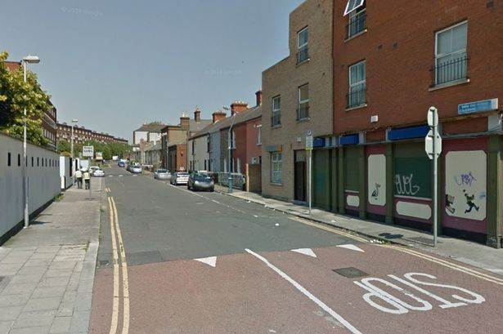

Figure AR 10 Coleraine Street (looking north towards Constitution Hill) (Source Google Earth)

The Church Street section of the EPR is one of the more constrained with limited scope to provide the full CBC cross-section (Bus, Traffic and Cycle Lanes). For the Concept Design an option which includes traffic lanes in both direction and bus lane in the northbound direction is proposed. For bus priority in the southbound direction, a bus gate at North King Street will meter the traffic into the following section and will allow the CBC buses to pass the queuing traffic. Cyclists are provided with a cycle lane where space is available, however over most of this 0.5km section they will need to share with buses within the bus lanes, or use the alternative route via Beresford Street.

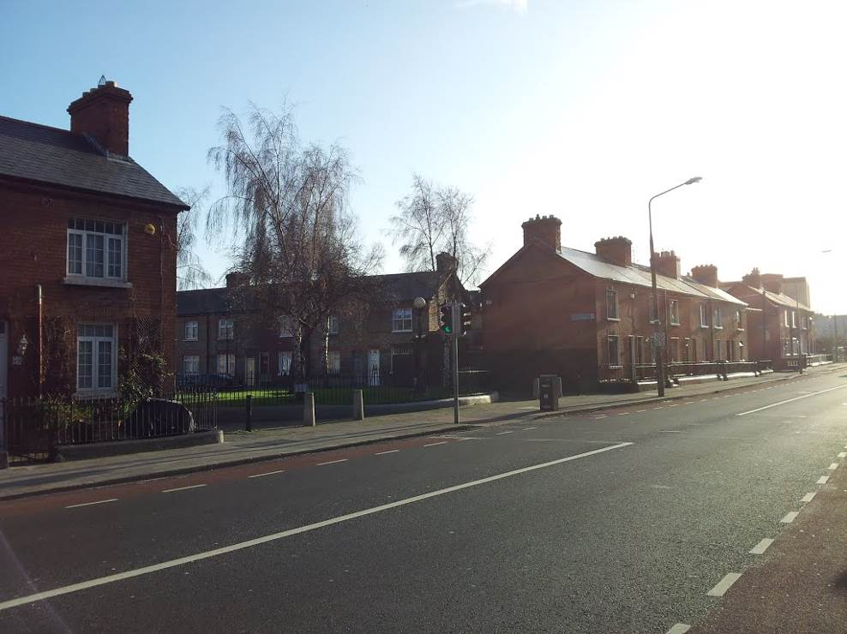

Figure AR 11 Church Street looking south (Father Mathew Square opposite)

Population Catchment
The proposed stop locations are indicated in the drawings for the scheme. The residential catchment within 5, 10 and 15 minutes walking distance of the proposed stops was measured using a standard walking pace. The population residing within each of these categories is summarised below:
- 0-5 minutes walking distance – 16,524 residents
- 5-10 minutes walking distance – 32,095 residents
- 10-15 minutes walking distance – 43,703 residents
- Total catchment within 15 minutes walking distance – 92,600 residents

These figures are based on the Census 2011 Small Area Population Statistics (SAPS). Furthermore, there are a total of 83,664 people working or attending an educational institution within the 15 minute walking catchment of the CBC stops i.e. 58,950 in employment and 24,714 in education.

In general the areas surrounding this corridor are linked together through series of interconnecting streets, resulting in a fairly permeable environment. The few exceptions are Glasnevin Cemetery and various sports grounds, which do not require additional permeability from this corridor.

