Ringsend - City Centre Core Bus Corridor
Problem Identification Report

National Transport Authority

Project Number: 60507750

21 November 2016

Quality information
Prepared by |  | Checked by |  | Approved by
Fearghal Malone  Graduate Consultant |  | Dimitris Karakaxas |  | Dimitris Karakaxas

Revision History
Revision | Revision date | Details | Authorized | Name | Position

Distribution List
# Hard Copies | PDF Required | Association / Company Name

Prepared for:
National Transport Authority

Prepared by:
Fearghal Malone
Graduate Consultant
T: (01) 238 3125
M: 0863820389
E: fearghal.malone@aecom.com

‌AECOM Ireland Limited
4th Floor
Adelphi Plaza
Georges Street Upper
Co. Dublin
Ireland

T: +353 1 238 3100
aecom.com

© 2016 AECOM Ireland Limited. All Rights Reserved.
This document has been prepared by AECOM Ireland Limited (“AECOM”) for sole use of our client (the “Client”) in accordance with generally accepted consultancy principles, the budget for fees and the terms of reference agreed between AECOM and the Client. Any information provided by third parties and referred to herein has not been checked or verified by AECOM, unless otherwise expressly stated in the document. No third party may rely upon this document without the prior and express written agreement of AECOM.

Table of Contents
1. Introduction 7
2. Ringsend – City Centre Route Options 9
2.1 Route Option R1: Bath Street/Pembroke Street/Irishtown Road/Bridge Street/Ringsend Road/Pearse Street/Sandwith Street Lower 9
2.1.1 Route Map 9
2.1.2 Cycle Facilities 9
2.1.3 Road condition 11
2.1.4 Pinch Points 13
2.1.5 Footpath Condition 14
2.1.6 Mobility Impaired and Disabled (MID) 15
2.1.7 Dangerous Structures/Buildings 17
2.1.8 Public Lighting 17
2.1.9 Access Points 17
2.1.10 Electricity Poles 17
2.2 Route Option R2: Irishtown Road/Bridge Street/Ringsend Road/Pearce Street/Sandwith Street Lower 18
2.2.1 Route Map 18
2.2.2 Cycle Facilities 18
2.2.3 Road condition 19
2.2.4 Pinch Points 19
2.2.5 Footpath Condition 19
2.2.6 Mobility Impaired and Disabled (MID) 20
2.2.7 Dangerous Structures/Buildings 21
2.2.8 Public Lighting 21
2.2.9 Access Points 21
2.2.10 Electricity Poles 22
2.3 Route Option R3: Seán Moore Road/Pidgeon House Road/Cambridge Road/Thorncastle Street/ Bridge Street/Ringsend Road/Pearce Street/Sandwith Street Lower 23
2.3.1 Route Map 23
2.3.2 Cycle Facilities 23
2.3.3 Road condition 25
2.3.4 Pinch Points 25
2.3.5 Footpath Condition 26
2.3.6 Mobility Impaired and Disabled (MID) 27
2.3.7 Dangerous Structures/Buildings 29
2.3.8 Public Lighting 29
2.3.9 Access Points 29
2.3.10 Electricity Poles 29
2.4 Route Option R4: Church Avenue/Sean Moore Road/R131/Sir John Rogerson’s Quay/City Quay/Lombard Street East 30
2.4.1 Route Map 30
2.4.2 Cycle Facilities 30
2.4.3 Road condition 31
2.4.4 Pinch Points 33
2.4.5 Footpath Condition 33
2.4.6 Mobility Impaired and Disabled (MID) 34
2.4.7 Dangerous Structures/Buildings 36
2.4.8 Public Lighting 36
2.4.9 Access Points 36
2.4.10 Electricity Poles 36
Appendix A Document copies 37
A.1 App heading 2 37

Figures
Figure 2.1-1: R1 Route Map 9
Figure 2.1-2: Lack of cycle facilities Bath Street 10
Figure 2.1-3: Lack of cycle facilities Pearse street 10
Figure 2.1-4: Lack of thermoplastic material and cycle markings Irishtown Road 10
Figure 2.1-5: Lack of thermoplastic material and cycle markings Ringsend Road 11
Figure 2.1-6: Example of poor road condition, Bay View 11
Figure 2.1-7: Example of dilapidated road condition Irishtown Road 11
Figure 2.1-8: Poor road condition 12
Figure 2.1-9: Poor road condition at the junction of Ringsend Road and Barrow Street 12
Figure 2.1-10: Poor road condition Sandwith Street Lower 12
Figure 2.1-11: Bus Stop Markings in poor condition Pearse Street 13
Figure 2.1-12: Parking space markings in poor condition Pearse Street 13
Figure 2.1-13: Example of pinch point on Bath Street 13
Figure 2.1-14: Example of cycle facilities Pembroke Road 14
Figure 2.1-15: Footpath in dilapidated condition, Bath Street 14
Figure 2.1-16: Example of footpath condition travelling south – north along Bay View 14
Figure 2.1-17: Footpath in poor condition travelling east – west along Ringsend Road 15
Figure 2.1-18: Missing tactile paving at junction of Bath Street and Herbert Place 15
Figure 2.1-19: Missing tactile paving and unsuitable dishing at junction of Bayview and Church Avenue 16
Figure 2.1-20: Lack of tactile paving and dishing at junction of Pembroke Street and Irishtown Road 16
Figure 2.1-21: Missing tactile paving Ringsend Road 17
Figure 2.1-22: Lack of tactile paving at the junction of Pearse Street and Brunswick Place 17
Figure 2.2-1: R2 Route Map 18
Figure 2.2-2: Example of lack of cycle facilities looking South – North along Irishtown Road 19
Figure 2.2-3: Road condition at rear entrance of Garda barracks, Irishtown Road 19
Figure 2.2-4: Footpath in poor condition on approach to Irishtown/Pembroke street junction travelling south-north 20
Figure 2.2-5: Lack of tactile paving at Irishtown Road/Barrack Lane junction 20
Figure 2.2-6: Lack of tactile paving at junction of Irishtown Road and Dodder Terrace 21
Figure 2.2-7: Access point Dodder Terrace 22
Figure 2.3-1: R3 Route Map 23
Figure 2.3-2: Lack of Cycle Facilities, Seán Moore road 24
Figure 2.3-3: Example of the lack of cycle facilities on Pidgeon House Road 24
Figure 2.3-4: Example of the lack of cycle facilities on Cambridge Road 24
Figure 2.3-5: Example of the lack of cycle facilities along Thorncastle Road 25
Figure 2.3-6: Road markings in poor condition Seán Moore roundabout 25
Figure 2.3-7: Poor road condition at Pidgeon house Road/Cambridge Avenue junction 25
Figure 2.3-8: Footpath below required minimum width of 1.8m Pidgeon House Road 26
Figure 2.3-9: Section of footpath in dilapidated condition, crossing point Seán Moore Road 26
Figure 2.3-10: Traffic signage causing obstruction in footpath Seán Moore road 27
Figure 2.3-11: Lack of tactile paving crossing point Seán Moore Road 27
Figure 2.3-12: Lack of tactile paving and unsuitable dishing at junction of Seán Moore road and Beach Road 28
Figure 2.3-13: Lack of tactile paving Seán Moore/Bremen Road junction 28
Figure 2.3-14: Lack of tactile paving at junction of Cambridge Avenue and Cambridge Park 29
Figure 2.3-15: Lack of tactile paving at Thorncastle Street/Bridge Street junction 29
Figure 2.4-1: Route Map Option R4 30
Figure 2.4-2: Example of the lack of cycle facilities on the R131 31
Figure 2.4-3: Lack of cycle facilities on Sir John Rogerson’s Quay 31
Figure 2.4-4: Lack of cycle lane markings Lombard Street East 31
Figure 2.4-5: Poor road condition Sir John Rogerson’s Quay 32
Figure 2.4-6: Poor road condition Sir John Rogerson’s Quay 32
Figure 2.4-7: Poor Road Pavement condition Lombard Street East 33
Figure 2.4-8: Poor road marking conditions Lombard Street East 33
Figure 2.4-9: Example of the lack of footpath facilities on the R131 34
Figure 2.4-10: Lack of Tactile paving Seán Moore/R131 Roundabout 34
Figure 2.4-11: Lack of tactile paving at junction of Sir John Rogerson’s Quay and Britain Quay 34
Figure 2.4-12: Lack of tactile paving at junction of Sir John Rogerson’s Quay and Asgard Road 35
Figure 2.4-13: Lack of tactile paving at junction of Sir John Rogerson’s Quay and Lime Street 35
Figure 2.4-14: Lack of tactile paving at the junction of Lombard Street East and Lombard Court 36

Tables
No table of figures entries found.

Introduction
AECOM have been tasked by the National Transport Authority (NTA) to identify viable routes for a Core Bus Corridor which aims to provide ease of bus travel with the objective of improving journey times from South County Dublin into Dublin City Centre.
This report shall seek to identify problems with the existing conditions in the road network. Each route was assessed using criteria specified by the NTA. The criteria are listed as follows:
- Cycle Facilities – Each road along the possible route options were checked to see if cycle facilities such as cycle tracks have been provided and if so, the condition of the construction materials used.
- Road Condition - The roads along each route were assessed to determine the existing conditions of the road pavement, both the condition of the existing surface course and also the visibility of road markings, both in the carriageway and at existing bus stops.
- Pinch Points - Pinch points were assessed on whether each route could provide the minimum road standard width requirement to provide a two-way carriageway, a cycle track and a footpath. In areas that roads do not provide the minimum widths required these areas are identifiable as “pinch points”.

- Footpath Condition - The condition of the footpaths were also assessed along the possible route options to check for sections which have become dilapidated over time. The footpaths were also checked for uprights and traffic signs which may cause obstructions to pedestrians.
- Mobility Impaired and Disabled – Each road on the route options were assessed to determine if the correct facilities have been provided to ensure unrestricted movement, in the safest possible manner, for people with mobility impairments.
- Dangerous Structures/Buildings - Along each route, any buildings or structures which may potentially pose a health and safety risk to the general public and which may pose a hazard during any proposed construction works were recorded.
- Public Lighting – Public lighting columns along each route have been checked for damage. Any damage to the existing public lighting which may pose a hazard to the general public, and the location of same, was then duly recorded.
- Access Points – Each access point has been assessed to analyse the condition of pavements.
- Electricity Poles – Electricity Poles along each of the separate route options have been checked for damage. The location of the damaged poles have been recorded and also the damage that has occurred.

Ringsend – City Centre Route Options

Route Option R1: Bath Street/Pembroke Street/Irishtown Road/Bridge Street/Ringsend Road/Pearse Street/Sandwith Street Lower

Route Map
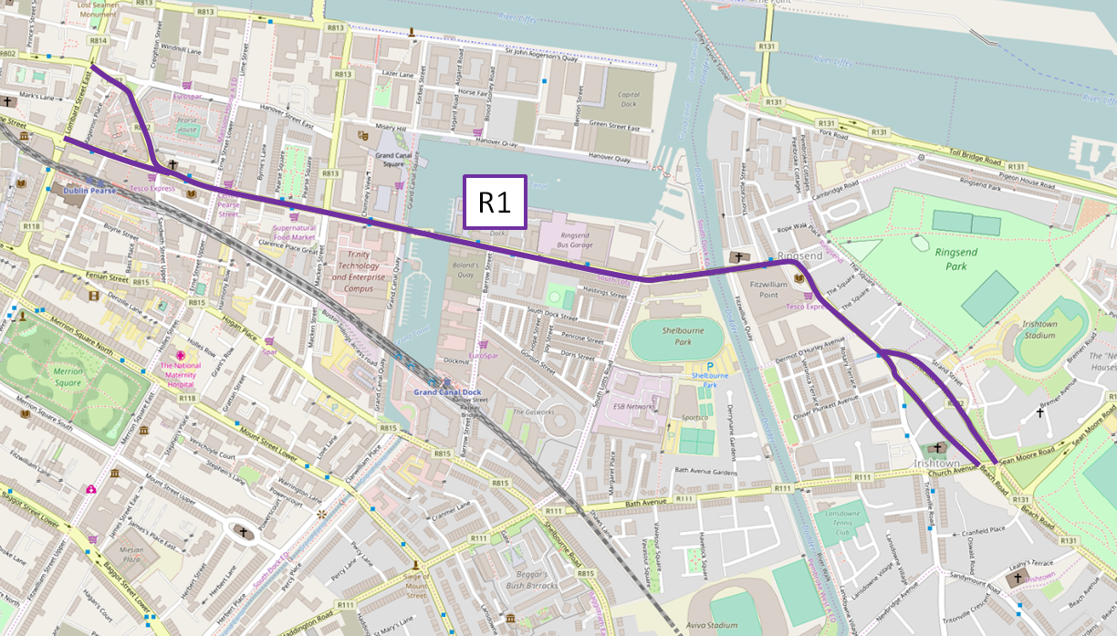
Figure 2.1-1: R1 Route Map

Cycle Facilities
There is a lack of cycle facilities at numerous locations on the route. Also at several locations along the route, cycle lanes have been provided but not constructed using the standard thermoplastic material. A full list of the problems identified with the cycle facilities along this route are contained within Table --- below.

Road condition
Following assessment of the route in numerous locations both the road pavement and markings were found to be in poor condition. A full list of the problems identified with the road pavement and markings along this route are contained within Table ---.

Pinch Points
Two pinch points have been identified during the course of this assessment on Bath Street.

Footpath Condition
The survey has identified locations along the route where footpaths are in poor condition, examples of which can be seen on Bath Street, travelling south – north along Bay View and travelling east – west along Ringsend Road. A full list of the problems identified with the footpaths along this route is contained within Table ---

Mobility Impaired and Disabled (MID)
The survey has identified locations along the route were tactile paving is not provided. A full list of missing MID facilities and locations is contained Table ---.

Dangerous Structures/Buildings
No problems were found with the existing structures and buildings along this route.

Public Lighting
No problems were found with the existing public lighting along this route.

Access Points
No problems were found with the existing access points along this route.

Electricity Poles
No problems were found with the existing electricity poles along this route.

Route Option R2: Irishtown Road/Bridge Street/Ringsend Road/Pearce Street/Sandwith Street Lower

Route Map
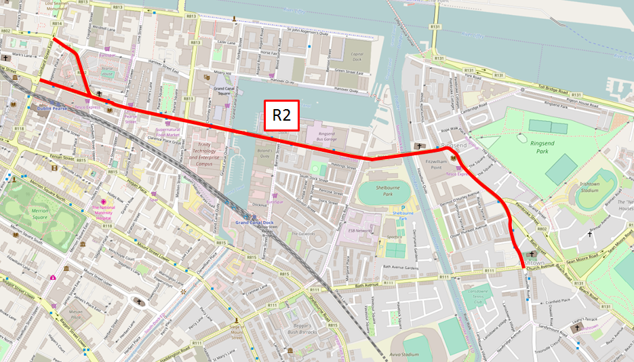
Figure 2.2-1: R2 Route Map
Route Option R2 begins at the junction of Irishtown road and Church Avenue. The route follows Irishtown Road before taking the same route as Option R1 i.e. along Bridge Street, Ringsend Road etc. Therefore the same issues identified in the R1 Route Option survey from the Bath Street/Pembroke Street/Irishtown road junction, are also applicable to the R2 Route Option Survey.

Cycle Facilities
There are no cycle facilities along Irishtown Road, from the junction at Church Avenue to the junction of Irishtown Road and Pembroke Street. For all other problems with cycle facilities on this route see Route Option R1.

Road condition
Following assessment of Irishtown Road one location was identified were the road pavement and markings were found to be in poor condition. For all other problems identified on this route see Route Option R1.

Pinch Points
No problems were found with pinch points along this route.

Footpath Condition
Following assessment of Irishtown Road one location was identified were the road pavement and markings were found to be in poor condition. For all other problems identified on this route see Route Option R1.

Mobility Impaired and Disabled (MID)
Following assessment of Irishtown Road two locations were identified were road crossings lacked the necessary tactile paving. These can be found at the Irishtown Road/Barrack Lane junction and at the junction of Irishtown Road and Dodder Terrace. For all other problems identified on this route see Route Option R1.

Dangerous Structures/Buildings
No problems were found with the existing structures and buildings along this route.

Public Lighting
No problems were found with the existing public lighting along this route.

Access Points
One problem was identified on this route whilst conducting this survey, namely the poor condition of the road pavement at the entrance to Dodder Terrace from Irishtown Road.

Electricity Poles
No problems were found with the existing electricity poles along this route.

Route Option R3: Seán Moore Road/Pidgeon House Road/Cambridge Road/Thorncastle Street/ Bridge Street/Ringsend Road/Pearce Street/Sandwith Street Lower

Route Map
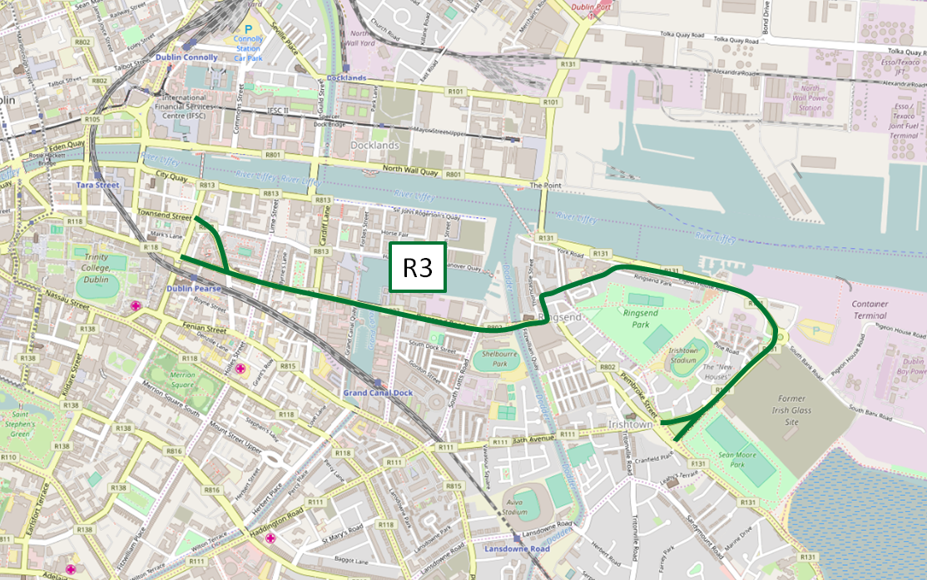
Figure 2.3-1: R3 Route Map
Route Option R3 begins at the junction of Irishtown road and Church Avenue. The route follows Seán Moore Road before taking the same route as Option R1 and R2 i.e. along Bridge Street, Ringsend Road etc. Therefore the same issues identified in the R1 Route Option survey from the Thorncastle Road/Bridge Street junction, are also applicable to the R3 Route Option Survey.

Cycle Facilities
As a result of the study, a lack of cycle facilities were identified at a number of locations namely Seán Moore Road, Pidgeon House Road, Cambridge Road and Thorncastle Street. For all other problems with cycle facilities on this route see Route Option R1.

Road condition
Following assessment of the route from Seán Moore Road to the Thorncastle Street/ Bridge Street junction several locations were identified were the road pavement and markings were found to be in poor condition. For all other problems identified on the second half of this route see Route Option R1. A full list of the problems identified along this route is contained on Table ---.

Pinch Points
Following the survey, one pinch point, where the footpath does not meet the required standard width of 1.8m, was identified on the route on Pidgeon House Road approaching Cambridge Avenue travelling east - west.

Footpath Condition
The majority of the footpaths along the first half of the route are in good condition. Problems were identified at two locations from Seán Moore Road to the junction of Thorncastle Street and Bridge Street. The second half of this route option follows the same route as Option R1 namely along Bridge Street, Ringsend Road etc., therefore encountering the same footpath conditions as detailed in section Route Option R1 above.

Mobility Impaired and Disabled (MID)
The survey has identified locations along the route were MID facilities are not provided. A full list of missing facilities and locations are contained on Table ---.

Dangerous Structures/Buildings
No problems were found with the existing structures and buildings along this route.

Public Lighting
No problems were found with the existing public lighting along this route.

Access Points
No problems were found with the existing public lighting along this route.

Electricity Poles
No problems were found with the existing public lighting along this route.

Route Option R4: Church Avenue/Sean Moore Road/R131/Sir John Rogerson’s Quay/City Quay/Lombard Street East

Route Map
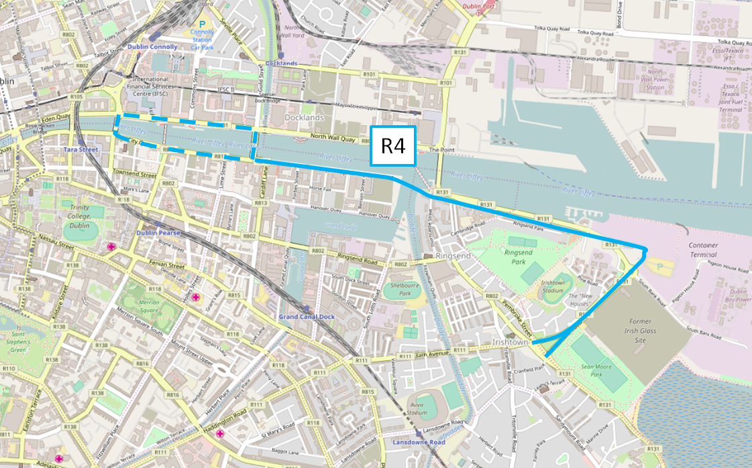
Figure 2.4-1: Route Map Option R4
The first section of this route follows Seán Moore Road and as such, the problems have already been recorded in the Route Option R3 section above. This section shall therefore categorize the problems identified starting at the Seán Moore/Pidgeon House Road/R131 roundabout.

Cycle Facilities
The survey identified several locations along the route which have a lack of cycling facilities including along the R131, Sir John Rogerson’s Quay and on Lombard Street East.

Road condition
The road pavements along Sir John Rogerson’s quay and Lombard Street East were generally found to be in poor condition.

Pinch Points
No problems were found with pinch points along this route.

Footpath Condition
Following assessment of Irishtown Road one location was identified were footpath facilities have not been provided, on the R131.

Mobility Impaired and Disabled (MID)
The survey has identified locations along the route were tactile paving is not provided, namely at the Seán Moore/R131 Roundabout, at the junction of Sir John
Rogerson’s Quay and Britain Quay, at the junction of Sir John Rogerson’s Quay and Asgard Road, at the junction of Sir John Rogerson’s Quay and Lime Street and at the junction of Lombard Street East and Lombard Court. A full list of missing MID facilities and locations is contained on Table ---.

Dangerous Structures/Buildings
No problems were found with the existing structures and buildings along this route.

Public Lighting
No problems were found with the existing public lighting along this route.

Access Points
No problems were found with the existing public lighting along this route.

Electricity Poles
No problems were found with the existing public lighting along this route.
- Document copies
- App heading 2

Numbered copies
Number: | <DocumentCopy> | Copies to: | <Copy recipient 1>  <Copy recipient 2>  <Copy recipient 3>

Fearghal Malone
Graduate Consultant
T: (01) 238 3125
M: 0863820389
E: fearghal.malone@aecom.com

AECOM Ireland Limited
4th Floor
Adelphi Plaza
Georges Street Upper
Co. Dublin
Ireland

T: +353 1 238 3100
aecom.com

