Ringsend - City Centre Core Bus Corridor
Problem Identification Report

National Transport Authority

Project Number: 60507750

29 November 2016

Quality information
Prepared by |  | Checked by |  | Approved by
Fearghal Malone  Graduate Consultant |  | Dimitris Karakaxas |  | Dimitris Karakaxas

Revision History
Revision | Revision date | Details | Authorized | Name | Position

Distribution List
# Hard Copies | PDF Required | Association / Company Name

Prepared for:
National Transport Authority

Prepared by:
Fearghal Malone
Graduate Consultant
T: (01) 238 3125
M: 0863820389
E: fearghal.malone@aecom.com

‌AECOM Ireland Limited
4th Floor
Adelphi Plaza
Georges Street Upper
Co. Dublin
Ireland

T: +353 1 238 3100
aecom.com

© 2016 AECOM Ireland Limited. All Rights Reserved.
This document has been prepared by AECOM Ireland Limited (“AECOM”) for sole use of our client (the “Client”) in accordance with generally accepted consultancy principles, the budget for fees and the terms of reference agreed between AECOM and the Client. Any information provided by third parties and referred to herein has not been checked or verified by AECOM, unless otherwise expressly stated in the document. No third party may rely upon this document without the prior and express written agreement of AECOM.

Table of Contents
1. Introduction 6
1.1.1 Legend 6
2. Ringsend – City Centre Route Options 7
2.1 Route Option R1: Irishtown Road/Bridge Street/Ringsend Road/Pearce Street/Sandwith Street Lower 7
2.1.1 Route Map 7
2.1.2 Irishtown Road 7
2.1.3 Bridge Street 7
2.1.4 Ringsend Road 7
2.1.5 Pearse Street 8
2.1.6 Sandwith Street 8
2.2 Route Option R2: Bath Street/Pembroke Street/Irishtown Road/Bridge Street/Ringsend Road/Pearse Street/Sandwith Street Lower 9
2.2.1 Route Map 9
2.2.2 Bath Street 9
2.2.3 Pembroke Street 9
2.2.4 Irishtown Road 10
2.3 Route Option R3: Seán Moore Road/Pidgeon House Road/Cambridge Road/Thorncastle Street/ Bridge Street/Ringsend Road/Pearce Street/Sandwith Street Lower 11
2.3.1 Route Map 11
2.3.2 Seán Moore Road 11
2.3.3 Pidgeon House Road 11
2.3.4 Cambridge Road 12
2.3.5 Thorncastle Street 12
2.4 Route Option R4: Church Avenue/Sean Moore Road/R131/Sir John Rogerson’s Quay/City Quay 12
2.4.1 Route Map 12
2.4.2 R131 13
2.4.3 Sir John Rogerson’s Quay 13
2.4.4 City Quay 13
Appendix A Document copies 14
A.1 App heading 2 14

Figures
Figure 2.1-1: R1 Route Map 6
Figure 2.2-1: R2 Route Map 8
Figure 2.3-1: R3 Route Map 10
Figure 2.4-1: Route Map Option R4 11

Tables
No table of figures entries found.

Introduction
AECOM have been tasked by the National Transport Authority (NTA) to identify viable routes for a Core Bus Corridor which aims to provide ease of bus travel with the objective of improving journey times from Ringsend into Dublin City Centre.
This report shall seek to identify the parking conditions in the existing road network. Each route was assessed using criteria specified by the NTA. The assessment criteria for the existing parking on the separate routes are listed as follows:
- Formal Parking: On-street parking in which marked spaces has been provided. These are spaces in which the Local Authority charges an hourly rate to use.
- Informal Parking: On-street parking in which spaces may or may not be marked and in which the Local Authority does not charge for use.
- Adjacent Parking: Parking which is accessible to the general public and is located in close proximity to the street. These are spaces in which the Local Authority charges an hourly rate to use.
- Taxi Facilities: Parking spaces which have been allocated for use by taxi services only.

Legend
- This colour represents sections along a route which has no parking facilities.
- This colour represents sections along a route which has formal parking facilities.
- This colour represents sections along a route which has informal parking facilities.
- This colour represents sections along a route which has adjacent parking facilities.
- This colour represents sections along a route which have taxi facilities.

Ringsend – City Centre Route Options

Route Option R1: Irishtown Road/Bridge Street/Ringsend Road/Pearce Street/Sandwith Street Lower

Route Map
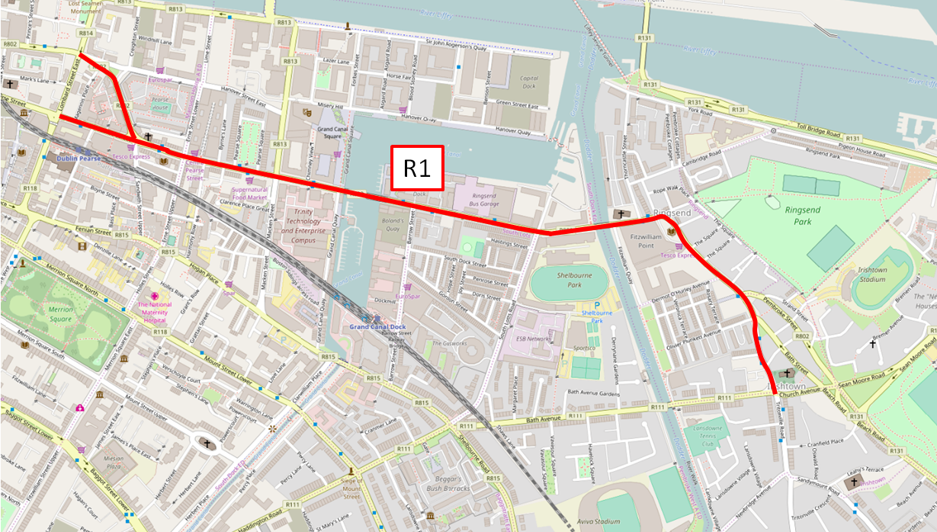

Irishtown Road
There is evidence of formal and informal on-street parking and also some adjacent parking along Irishtown Road. The parking breakdown on Irishtown Road is as follows:
- Formal Parking – 10 (Of which 3 are disabled parking) spaces.
- Informal Parking – Approximately 66 spaces.
- Adjacent Parking – Approximately 12 spaces.

Bridge Street
There are no parking facilities along the entire length of Bridge Street.

Ringsend Road
The survey has shown that there is formal parking available at the locations along Ringsend Road.
- Formal Parking – Approximately 12 spaces

Pearse Street
The survey has shown that there is formal parking available at the locations along Pearse Street. The parking breakdown on Irishtown Road is as follows:
- Formal Parking – Approximately 61 spaces.
- Informal Parking – Approximately 7 spaces.

Sandwith Street
The survey has shown that there is formal parking available at the locations along Sandwith Street. The parking breakdown on Sandwith Street is as follows:
- Formal Parking – Approximately 28 spaces.
- Coach Parking – Approximately 4 spaces.

Route Option R2: Bath Street/Pembroke Street/Irishtown Road/Bridge Street/Ringsend Road/Pearse Street/Sandwith Street Lower

Route Map
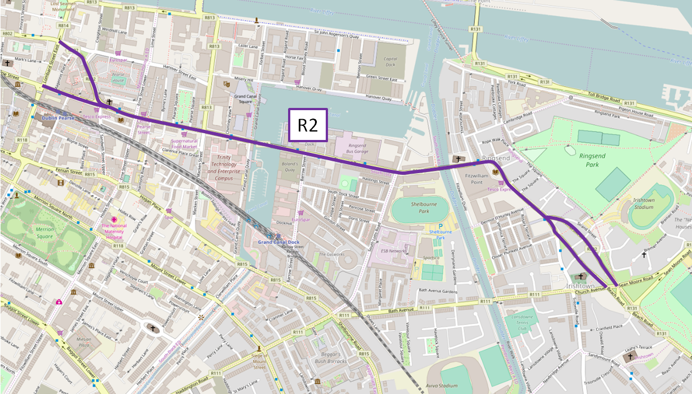
Route Option R2 follows Irishtown Road before taking the same route as Route Option R1 i.e. along Bridge Street, Ringsend Road etc. Therefore the same car parking facilities identified in the R1 Route Option survey from the Bath Street/Pembroke Street/Irishtown road junction are also applicable to the R2 Route Option Survey.

Bath Street
Currently there are no defined parking spaces, except for 2 impaired mobility spaces. The parking breakdown on Bath Street is as follows:
- Formal Parking – 2 spaces.
- Informal Parking – Approximately 23 spaces.
- Adjacent Parking – 0 spaces.

Pembroke Street
The survey has identified informal on-street parking along Pembroke Street. The parking breakdown on Pembroke Street is as follows:
- Formal Parking – 0 spaces.
- Informal Parking – Approximately 29 spaces.
- Adjacent Parking – 0 spaces.
    - Irishtown Road
For the purposes of this report this section shall concentrate on the length of Irishtown road from the junction of Irishtown Road/Oliver Plunkett Avenue/Bath Street to the junction of Bridge Street.
There is evidence of formal and informal on-street parking and also some adjacent parking along Irishtown Road. The parking breakdown on Irishtown Road is as follows:
- Formal Parking – 10 (Of which 3 are disabled parking) spaces.
- Informal Parking – Approximately 44 spaces.
- Adjacent Parking – Approximately 12 spaces.

Route Option R3: Seán Moore Road/Pidgeon House Road/Cambridge Road/Thorncastle Street/ Bridge Street/Ringsend Road/Pearce Street/Sandwith Street Lower

Route Map
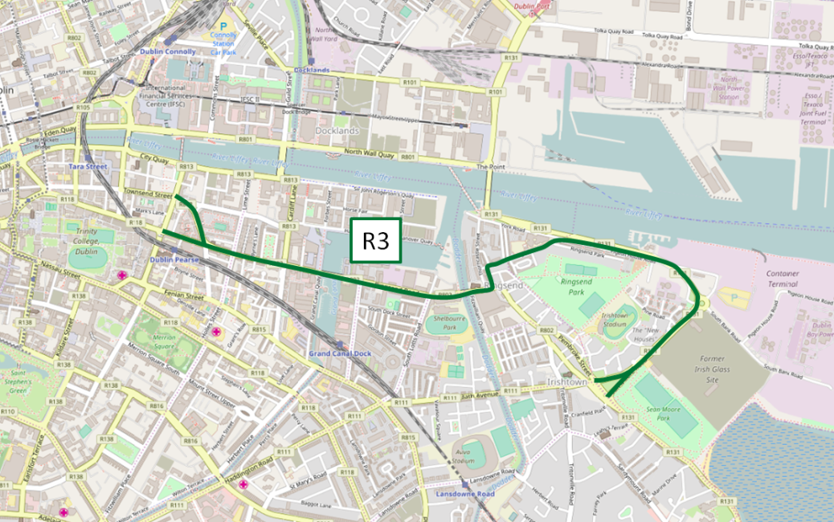
Route Option R3 begins at the junction of Irishtown road and Church Avenue. The route follows Seán Moore Road before taking the same route as Options R1 and R2 i.e. along Bridge Street, Ringsend Road etc. Therefore the same issues identified in the R1 Route Option survey from the Thorncastle Road/Bridge Street junction, are also applicable to the R3 Route Option Survey.
For the purposes of this report, this section will concentrate on the car parking facilities along Seán Moore Road, Pidgeon House Road, Cambridge Road and Thorncastle Street.

Seán Moore Road
There is no evidence of any car parking facilities along Seán Moore road.

Pidgeon House Road
The survey has identified informal on-street parking along Pidgeon House Road. There is no formal or adjacent car parking facilities on Pidgeon House Road. The parking breakdown on Pidgeon House Road is as follows:
- Formal Parking – 0 spaces.
- Informal Parking – Approximately 76 spaces.
- Adjacent Parking – 0 spaces.

Cambridge Road
The survey has identified both formal and informal on-street parking along Cambridge Road. There is no adjacent car parking facilities on Cambridge Road. The parking breakdown on Cambridge Road is as follows:
- Formal Parking – 7 spaces.
- Informal Parking – Approximately 110 spaces.
- Adjacent Parking – 0 spaces.

Thorncastle Street
The survey has identified formal on-street parking along Thorncastle Street. There is no informal or adjacent car parking facilities on Thorncastle Street. The parking breakdown on Thorncastle Street is as follows:
- Formal Parking – 32 spaces.
- Informal Parking – 0 spaces.
- Adjacent Parking – 0 spaces.

Route Option R4: Church Avenue/Sean Moore Road/R131/Sir John Rogerson’s Quay/City Quay

Route Map
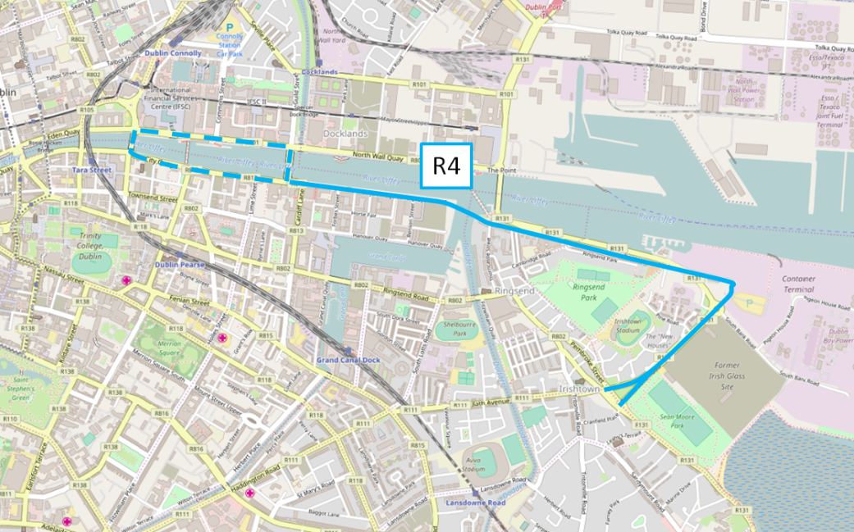
The first section of this route follows Seán Moore Road and as such, the problems have already been recorded Route Option R3 above. This section shall therefore concentrate on the car parking facilities identified on the R131, Sir John Rogerson’s Quay, City Quay and Lombard Street East starting at the Seán Moore/Pidgeon House Road/R131 roundabout.

Pidgeon House Road
The survey has identified informal on-street parking along Pidgeon House Road. There is no formal or adjacent car parking facilities on Pidgeon House Road. The parking breakdown on Pidgeon House Road is as follows:
- Formal Parking – 0 spaces.
- Informal Parking – Approximately 76 spaces.
- Adjacent Parking – 0 Spaces.

Sir John Rogerson’s Quay
The survey has identified formal, informal and taxi rank parking at numerous locations along Sir John Rogerson’s Quay. There is no adjacent car parking facilities on Sir John Rogerson’s Quay.
The parking breakdown on Sir John Rogerson’s Quay is as follows:
- Formal Parking – Approximately 67 spaces (Of which one is designated as Disabled parking).
- Informal Parking – 2 spaces.
- Taxi Rank – 3 spaces.
- Adjacent Parking – 0 spaces.

City Quay
The survey has identified formal on-street parking along City Quay. There is no informal or adjacent car parking facilities on City Quay. The parking breakdown on City Quay is as follows:
- Formal Parking – 24 spaces (Of which one has been designated Disabled Parking).
- Informal Parking – 0 spaces.
- Adjacent Parking – 0 spaces.

- Document copies
- App heading 2

Numbered copies
Number: | <DocumentCopy> | Copies to: | <Copy recipient 1>  <Copy recipient 2>  <Copy recipient 3>

Fearghal Malone
Graduate Consultant
T: (01) 238 3125
M: 0863820389
E: fearghal.malone@aecom.com

AECOM Ireland Limited
4th Floor
Adelphi Plaza
Georges Street Upper
Co. Dublin
Ireland

T: +353 1 238 3100
aecom.com

